Circuit Analysis
Lab 5
Assignment

Submitted by:
Wardah Shahid
2025-CE-81

University of Engineering
and Technology

Task 1:
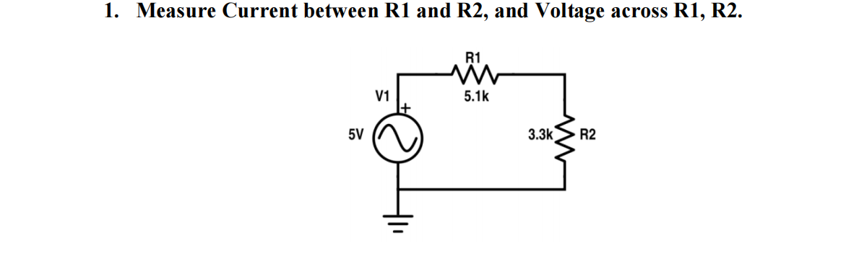
Circuit:
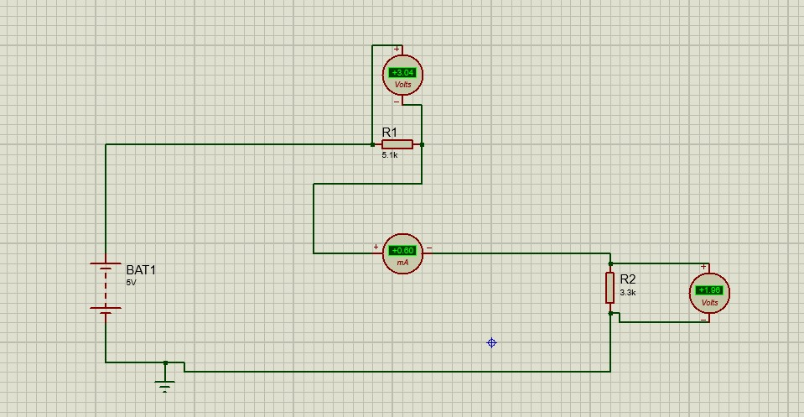

Procedure:
- Place the VSINE source on the schematic. Right-click it and select Edit Properties. Set the Amplitude to 5V. This represents your 5V AC input.
- Place two resistors, R1 and R2, in a series configuration.
- Double-click R1 and change its resistance to 5.1k.
- Double-click R2 and change its resistance to 3.3k. Connect the output of the source to the start of R1.
• Ammeters (Series): Delete the wire between R1 and R2, and place the
Ammeter in that gap so the current flows through it.

- Change the Display Range to Milliamps (mA) because the current will be very small.
• Voltmeters (Parallel): Place one AC Voltmeter across the terminals of R1 and another across the terminals of R2.
- Go to Terminals Mode, select GROUND, and connect it to the bottom wire of the circuit. Once everything is wired, click the Play (Run Simulation) button at the bottom left.

Table:
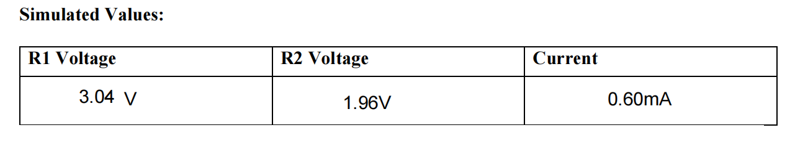
Task 2:
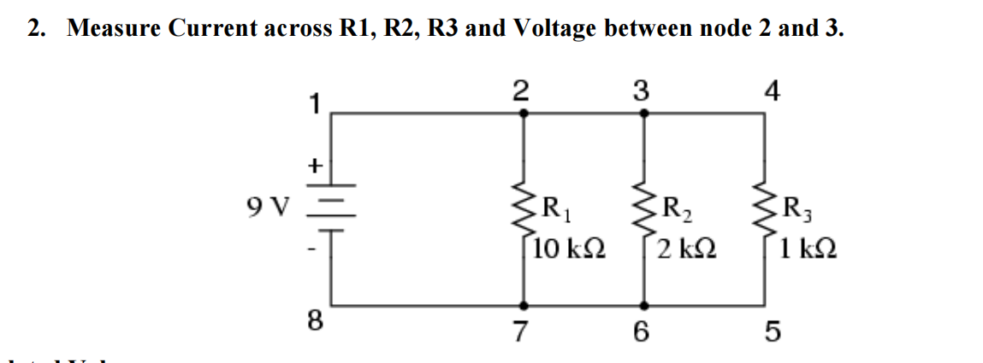

Circuit:
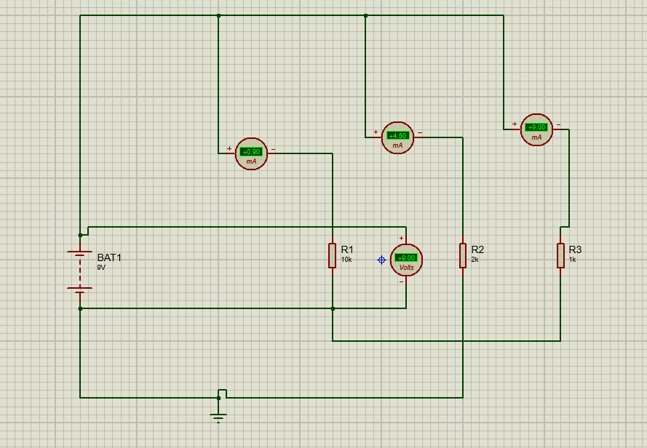

Explanation:
Open Proteus and use the 'P' (Pick Device) button to find:
- BATTERY: For the 9V DC source.
- RES: For the resistors.
- DC Ammeter: Found in the Instruments Mode (Left sidebar).
- DC Voltmeter: Found in the Instruments Mode.
- · Source: Place the Battery and set its value to 9V.
- · Resistors: Place three resistors and set their values:
- R1=10kohm
- R2=2kohm
- R3=1kohm
To measure the current for each resistor, you must place an Ammeter in series with each branch:
- Connect the Ammeter between Node 2 and R1.
- Connect another Ammeter between Node 3 and R2.
- Connect a third Ammeter between Node 4 and R3.
To measure the voltage between Node 2 and Node 3:
- Place a DC Voltmeter.
- Connect the positive (+) terminal to Node 2 and the negative (-) terminal to Node
Table:
